You need

# SharePoint list - Office usage weekly

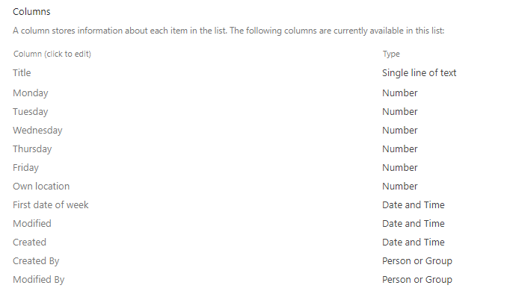

Advanced settings

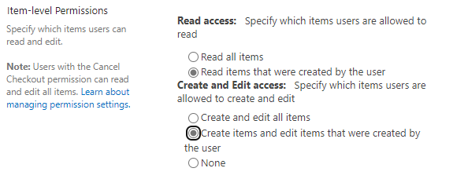

# SharePoint list - Office Usage Summary Weekly

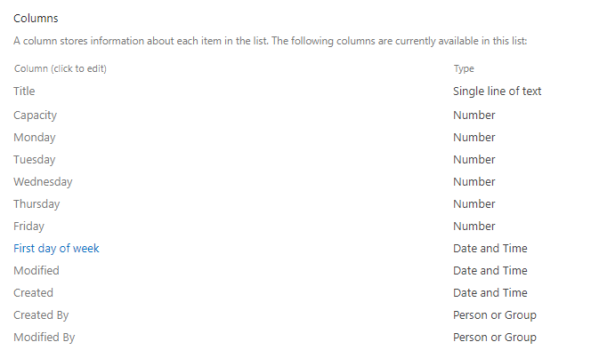

# Import Power Apps + Flow

# Note

Remember. This is not a product. This is just an example and source for inspiration. It is not properly tested.